Low Level Design (LLD)

Investment Analytics FDI`s

Revision Number: 1.1

`Date of revision: 02/06/2022

Abhishek

# Document Version Control

|  |  |  |  |
| --- | --- | --- | --- |
| Date Issued | Version | Description | Author |
| !1st .06.2021 | 1.1 | First Draft | Abhishek |
|  |  |  |  |

**Contents**

Document Version Control 2

**Abstract** 4

1 Introduction 5

1.1 Why this Low-Level Design Document? 5

1.2 Scope 6

1.3 Constraints 6

1.4 1.4 Risks 6

1.5 1.5 Out of Scope 7

2 Technical specifications 7

2.1 FDI`s datasets 7

2.2 Insight Patterns 7

2.3 Database 7

3 Technology stack 8

4 Proposed Solution 9

5 Model training/validation workflow 10

6 Stakeholders I/O workflow 12

7 Exceptional scenarios 13

**Abstract**

` Foreign Direct Investment (FDI) has registered a tremendous growth for several decades. The increased flows of FDI indicate the growing internationalization and integration of economic activities around the globe. At the same time, with the gradual change in the motives for FDI as well as the shift of some location specific advantages from developed to developing countries, the patterns and trends of FDI has been experiencing a significant change in recent past. The motives of the service have been shifting from more conventional resource or market seeking to efficiency or strategic asset seeking. Comparative cost factor has become the principal driving force for international production. Remarkable changes are also visible in the forms and sectorial pattern of international investments. The purpose of this paper is to trace the trajectory of the recent flows of FDI from global and regional perspective and to explore the reasons behind the prevailing trend and patterns

# Introduction

## Why this Low-Level Design Document?

The purpose of this document is to present a detailed description of the Investment Analytics ` System. It will explain the purpose and features of the system, the graphical interfaces of the system, what the system will do, the graphical constraints under which it must operate and how the system will react to external factors. This document is intended for both the stakeholders and the developers of the system and will be proposed to the higher management for its approval.

The main objective of the project is to predict if a person can get a appropriate decision making confident by institutes or individual in his/her future investment endeavour based on `Tableau based pattern recognition multi dimensional graphical evaluation .

GDP`s are a vital part of `financial nerve of nation and can:

* Contain potential factors to determine investment decision
* Allow access to evidence-based tools that providers can use to make decisions about a stakeholders FII
* Automate and streamline provider economic workflow

Tableau representation contains `insightful factors, such as:

* Data is interpreted as column headers (field names)Progress notes
* Vital signs
* `Data is interpreted as values in our data sources
* Data is derived from excel merged cell is interpreted as value in our data source`
* Tableau hardly makes change to our underlying data sourceAllergies
* Key for understanding data interpretation reports
* Approximation in forecasting

.

## Scope

This software system will be a Graph application. This system will be designed to detect the pattern at earliest for better decision management, improved interventions, and more efficient economic centric factors are resource allocation using previous FDI records available. More specifically, early detection of any preventable factors from data sources is important for better investment management. This system is designed to predict the sectors performance from leading information such as demographics, investment history, graph results, procedures and methods.

## Constraints

We will only be selecting a few of the worst performing sectors.

## Risks

Bottom performing sectors specific risks that have been identified or that should be considered.

## Out of Scope

Delineate specific activities, capabilities, and items that are out of scope for the project.

# Technical specifications

## 2.1 Dataset

|  |  |  |
| --- | --- | --- |
| **`Rows** | **Columns** | **Data Source** |
| Sectors | FYS | ` |
| ` |  |  |
| ` |  |  |
|  |  |  |

## 2.1.1 FDI`s dataset overview

Consists of 4 different tables, Patient table consists of the patient's personal information and most importantly we have the historic data of a patient in the table diagnosis. Whereas the transcript table consists of patient demographic data. Physician_speciality table consists of patient behaviour.

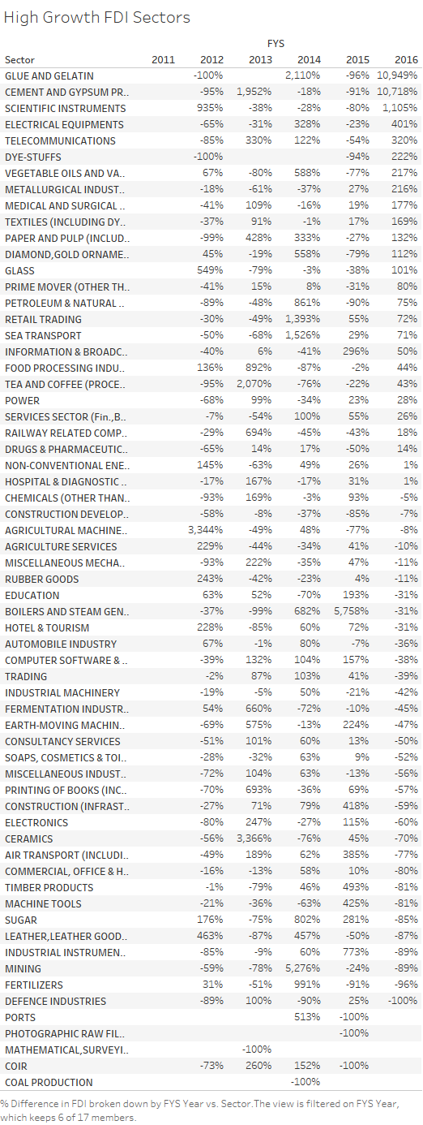

## 2.1.2 Input schema

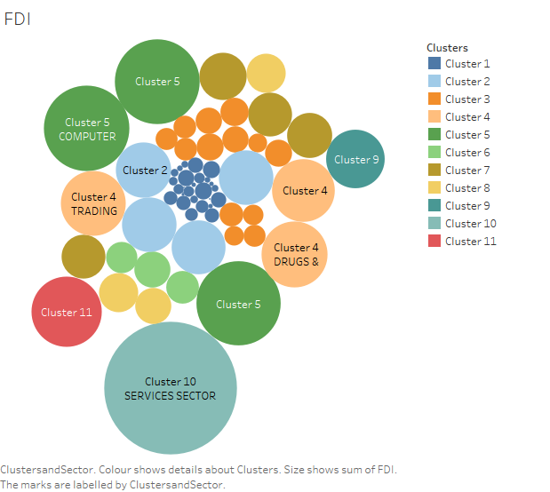

## 2.2 Predicting Decision

* The system displays the choices of the decision.
* The stakeholders choose the target sectors by clicking one of the available sections.
* The stakeholders select the intra factors of leading vibes.
* The system presents the set of inputs required from the stakeholders.
* The stakeholders give required information.
* The system should be able to predict whether worst factors for the chosen down performance based on the stakeholder information.

## 2.3 Insight patterns

We should be able to verify every sector done by the previous performance.

* The System identifies at what step actions required
* The System should be able to judge each and every system flow.
* Stakeholders can choose insightful methods based on forecasting. We can choose database ` as well.
* System should `debug after several revaluation

## 2.4 Database

System needs to store every request into the database and we need to store it in such a way that it is easy to retrain the model as well.

1. The Stakeholders must chooses the confidence for investment.

2. The stakeholder gives required information.

3. The system stores each and every data given by the stakeholders or received on request to the database. Database we can choose on own choice whether MongoDB/ MySQL.

**2.5 Deployment**

1. AWS



# Technology stack



# Model training/validation workflow

# Forecasting I/O workflow

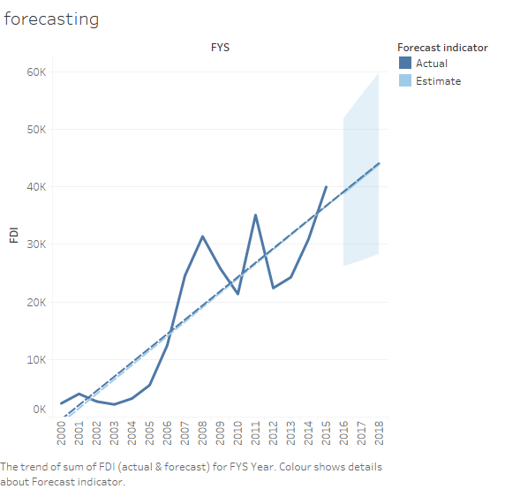

# Exceptional scenarios

|  |  |  |  |
| --- | --- | --- | --- |
| Step | Exception | Mitigation | Module |
| `01.06.2021 | 1.1 | First Draft | Abhishek |

# Test cases

|  |  |  |  |
| --- | --- | --- | --- |
| Test case | Steps to perform test case | Module | Pass/Fail |
|  |  |  |  |

# Key performance indicators (KPI)

* Key indicators displaying a summary of the anomaly detection in the society/Economies.
* Comparison of accuracy of model prediction and `stakeholder’s decision.
* Time and workload `efficiencies using the tableau based representation.
* On alert to nearest `evaluation on `several graphical insights.
* Measuring adequate factors of declining sectors.
* Deriving interoperability of investment moods
* Sufficient approximation of confidence centric investment decision